Preliminary Information on Takamatsu City
1. Access
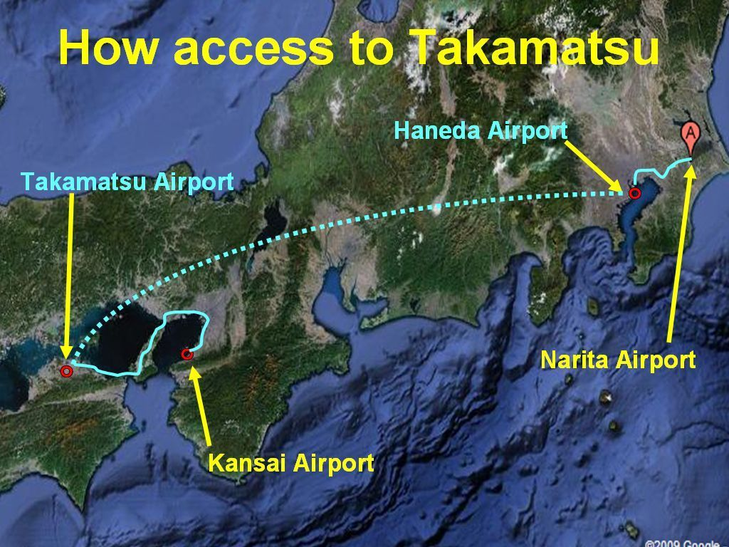
1-1 Via Tokyo/Narita
1-1-1 By domestic airlines
1) From Narita/Tokyo to Haneda/Tokyo Airport
It will take 100 minutes from Narita to Haneda Airport by bus.
http://www.limousinebus.co.jp/en/
The first bus is available at 7:00 in the morning and the last bus at 21:25.
In busiest hours, buses run every 15 minutes.
2) From Haneda/Tokyo Airport to Takamatsu Airport /Kagawa prefecture
It will take 75 minutes from Haneda to Takamatsu Airport by domestic airline.
Nine to ten flights every day.
http://www.ana.co.jp/asw/index.jsp?type=de
http://www.jal.co.jp/en/
3) From Takamatsu Airport to Takamatsu JR Station (near from meeting rooms and hotel)
It will take 45 minutes from Takamatsu Airport to Takamatsu JR* Station by bus.
http://www.takamatsu-airport.com/access/access_en.php#bus
1-1-2 By train (not shown in above figure)
1) From Narita/Tokyo to JR Tokyo Station
It will take 60 minutes from Narita to Tokyo Station by Narita Express.
http://jreast-shinkansen-reservation.eki-net.com/pc/english/common/timetable/index.html
2) From JR Tokyo Station to JR Okayama station
It will take 3 hours and 20 minutes from Tokyo Station to Okayama station by Shinkansen.
http://english.jr-central.co.jp/info/timetable/index.html
3) From JR Okayama Station to JR Takamatsu station through Seto-ohashi Bridge
It will take 60 minutes from JR Okayama Station to JR Takamatsu station by train.
*JR: Japan Railway
1-2 Via Kansai International Airport/Osaka
It will take 3,5 hours from Kansai Airport to JR Takamatsu station by bus.
2. Site information
2-1 Hotel
ANA Hotel Clement Takamatsu
http://www.ichotelsgroup.com/h/d/6c/1/en/hd/takja
2-2 Meeting facilities
Meeting | Date (Preliminary) | Room
WG1 | 2010-10-04 (Mon) ~ 10-06 (Wed) AM | Sunport hall Takamatsu 5F & 6F
WG3 | 2010-10-04 (Mon) ~ 2010-10-05 (Tue) | Sunport hall Takamatsu 5F & 6F
WG4 | 2010-09-27 (Mon) ~ 10-01 (Fri) | Sunport hall Takamatsu 5F & 6F
WG5 | 2010-10-05 (Tue) | Sunport hall Takamatsu 5F & 6F
WG8 | 2010-09-27 (Mon) ~ 10-01 (Fri) | Sunport hall Takamatsu 5F & 6F
WG10 | 2010-10-04 (Mon) ~ 2010-10-05 (Tue) | Sunport hall Takamatsu 5F & 6F
WG11 | 2010-10-04 (Mon) ~ 10-06 (Wed) | Sunport hall Takamatsu 5F & 6F
Plenary | 2010-10-06 (Wed) PM ~ 10-08 (Fri) | Kagawa International Conference Hall 6F
http://www.symboltower.com/hall/en/index.html
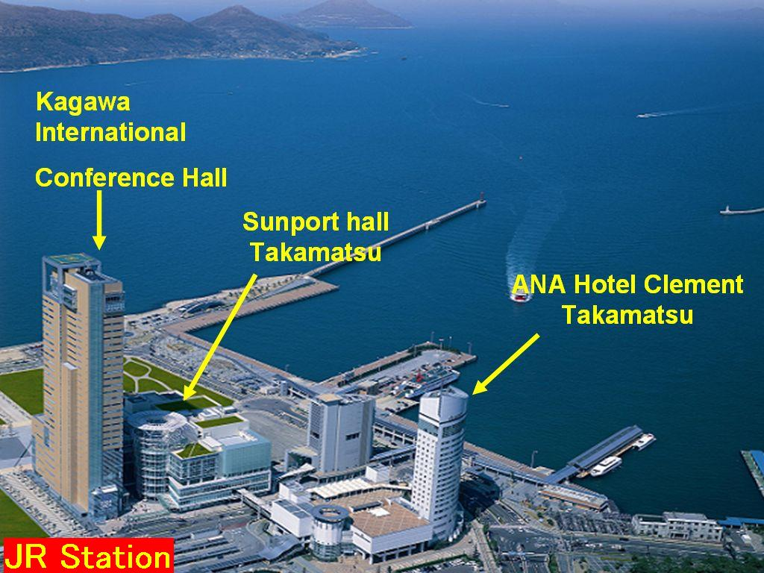
↑ ↑
JR Takamatsu station Bus terminal
One minute walk from JR Takamatsu station to the Site
3. Other information (Website in English)
Takamatsu city: http://www.city.takamatsu.kagawa.jp/ENGLISH/index.html
Art Festival: http://setouchi-artfest.jp/en/
Ritsurin park: http://www.pref.kagawa.jp/ritsurin/index_main_e.html
Map of Takamatsu City
